2015 SPTC Student of the Year (SOY) Award Nominee

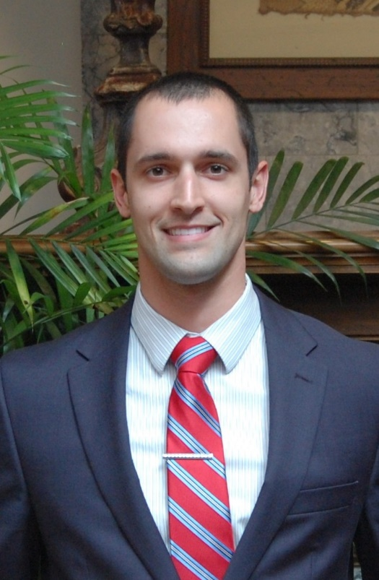
Nathan Ferraro
Program Director, Warrior-Scholar Project
Research Assistant, CEES
University of Oklahoma

Brief Biography

Nathan Ferraro of Pittsburgh, Pennsylvania is currently pursuing a master’s degree in civil engineering with an emphasis in geotechnical engineering under his advisor; Amy B. Cerato, Ph.D., P.E.; in the School of Civil Engineering and Environmental Science (CEES) at the University of Oklahoma. Ferraro has been the recipient of numerous honors and awards, including the Letzeiser Honor List, awarded to the top 13 male and female graduating seniors university-wide; 4.0 University Medallion, awarded for graduating with a perfect overall GPA; PE-ET – Top 10 Senior Honor Society, awarded to the top 10 seniors university-wide; President’s Award for Outstanding Transfer Student; Penn State’s President Sparks and President’s Freshman Awards; and 1st place at both the 2015 Gallogly College of Engineering’s Graduate Student Community Research Poster Fair and the 2014 University of Oklahoma’s Undergraduate Research Day. He also is the recipient of various scholarships, including the Dolese Tomorrow’s Engineer Scholarship, Terracon Foundation Scholarship, McNair Scholars Program, Guy Bradford Treat Memorial Scholarship, and the Society of American Military Engineers Scholarship.

Ferraro is a veteran of the U.S. Navy, having accumulated over 1,000 flight hours on the E-6B Mercury aircraft from 2008 to 2012. He worked as a supervisor for an eight man airborne communication team which provided a communications link between the President and the nation’s strategic nuclear forces. He was also active in multiple CEES organizations, including holding various leadership roles in the Architectural Engineering Institute (AEI) Student Chapter, the American Society of Civil Engineers (ASCE) Student Chapter, and the ASCE Concrete Canoe Competition Team, as well as an active member in Tau Beta Pi – the Engineering Honor Society and Chi Epsilon – the Civil Engineering Honor Society. Currently, Ferraro serves as the program director of OU’s Warrior-Scholar Project, which is an intensive week-long gateway program to help prepare college-bound veterans for the rigors of a four-year degree through social and academic curricula.

Outside of work and the classroom, Ferraro regularly competes in numerous athletic competitions for charity. He is an accomplished ultra-endurance athlete who has completed some of the most challenging single and multiday races in the world. He has finished eight 100 mile ultramarathons, with a personal best time of 19:19:15, as well as three 50 mile ultramarathons. His greatest athletic accomplishment includes finishing the infamous Badwater 135 Ultramarathon, a 135 mile trek through the deserts and mountain ranges of Death Valley, California in July when temperatures regularly exceed 115°F. Only 100 athletes world-wide are invited to compete. Additionally, Ferraro has completed six full triathlons (140.6 miles) since 2010. He has raise over $4,000.00 for various charities through his athletic endeavors.

